**Table Of Content:**

|  |  |  |
| --- | --- | --- |
| S. No | Content | Page No. |
| 1 | Certification Of Completion | 3 |
| 2 | Introduction | 4 |
| 3 | Project Objective | 6 |
| 4 | Problem Statement | 6 |
| 5 | Requirement Specification | 7 |
| 6 | Hardware and Software Requirement | 7 |
| 7 | Website with coding Screenshots | 8 |

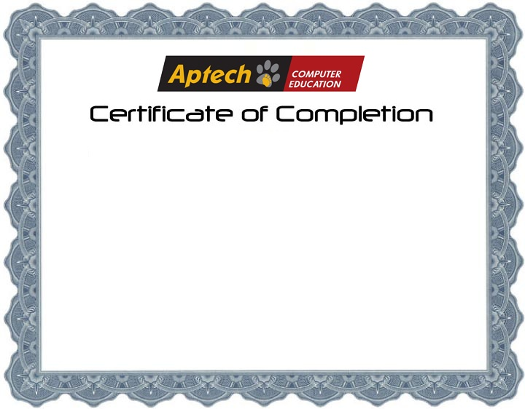

**This is to certify that web designing web development has been completed with all functionality by the students of PR2-202210C**

**Syed Hassan Ali” Abdul Ahad” Sheik Bilal” Abdul Rauf**

**Introduction:**

The thirst for learning, upgrading technical skills and applying the concepts in real life environment at a fast pace is what the industry demands from IT professionals today. However busy work schedules, far-flung locations, unavailability of convenient time-slots pose as major barriers when it comes to applying the concepts into realism. And hence the need to look out for alternative means of implementation in the form of laddered approach.

The above truly pose as constraints especially for our students too! With their busy schedules, it is indeed difficult for our students to keep up with the genuine and constant need for integrated application which can be seen live especially so in the field of IT education where technology can change on the spur of a moment. Well, technology does come to our rescue at such times!!

Keeping the above in mind and in tune with our constant endeavor to use Technology in our training model, we at Aptech have thought of revolutionizing the way our students learn and implement the concepts using tools themselves by providing a live and synchronous e-Project learning environment!

The thirst for learning, upgrading technical skills and applying the concepts in real life environment at a fast pace is what the industry demands from IT professionals today. However busy work schedules, far-flung locations, unavailability of convenient time-slots pose as major barriers when it comes to applying the concepts into realism. And hence the need to look out for alternative means of implementation in the form of laddered approach.

The above truly pose as constraints especially for our students too! With their busy schedules, it is indeed difficult for our students to keep up with the genuine and constant need for integrated application which can be seen live especially so in the field of IT education where technology can change on the spur of a moment. Well, technology does come to our rescue at such times!!

Keeping the above in mind and in tune with our constant endeavor to use Technology in our training model, we at Aptech have thought of revolutionizing the way our students learn and implement the concepts using tools themselves by providing a live and synchronous e-Project learning environment!

**So, what is this e-Project?**

e-Project is a step-by-step learning environment that closely simulates the classroom and Lab based learning environment into actual implementation. It is a project implementation at your fingertips!! An electronic, live juncture on the machine that allows you to

* Practice step by step i.e., laddered approach.
* Build a larger more robust application.
* Usage of certain utilities in applications designed by user.
* Single program to unified code leading to a complete application.
* Learn implementation of concepts in a phased manner.
* Enhance skills and add value.
* Work on real life projects.
* Give a real-life scenario and help to create applications more complicated and useful.
* Mentoring through email support.

The students at the center are expected to complete this e-Project and send complete project along with the documentation to e-Projects Team

Looking forward to a positive response from your end!!

e-Project is a step-by-step learning environment that closely simulates the classroom and Lab based learning environment into actual implementation. It is a project implementation at your fingertips!! An electronic, live juncture on the machine that allows you to

* Practice step by step i.e., laddered approach.
* Build a larger more robust application.
* Usage of certain utilities in applications designed by user.
* Single program to unified code leading to a complete application.
* Learn implementation of concepts in a phased manner.
* Enhance skills and add value.
* Work on real life projects.
* Give a real-life scenario and help to create applications more complicated and useful.
* Mentoring through email support.

The students at the center are expected to complete this e-Project and send complete project along with the documentation to e-Projects Team

Looking forward to a positive response from your end!!

**Project Objective:**

The Objective of this program is to give a sample project to work on real life projects. These applications help you build a larger more robust application.

The objective is not to teach you HTML/JavaScript/Dreamweaver but to provide you with a real-life scenario and help you create basic applications using the tools.

You can revise the chapters before you start with the project.

This project is meant for students who have completed the module of Dreamweaver. These programs should be done in the Lab sessions with assistance of the faculty if required.

It is very essential that a student has a clear understanding of the subject. Students should go through the project and solve the assignments as per requirements given.

Kindly get back to e-Projects Team in case of any doubts regarding the application or its objectives.

**Problem Statement:**

FANFAN Company is into manufacturing and selling on Fans. They manufacture fans for various needs of customers. From Ceiling Fans to Table Fans to Exhaust Fans, they are into all types of Fan Manufacturing.

They are looking to come up with their own website and display all the products available with them. They want to provide a detailed information about all their products.

**Requirement Specification:**

The Web site is to be created based on the following requirements.

* The Home Page should be created making use of Sections with a suitable logo, the header section can be added which will show images Fans.
* The site must contain the links to navigate through any category for the information.
* Links of bottles can be categorized like (Ceiling Fans, Table Fans, Exhaust etc.)
* Specification and Pricing of Fans can be added along with the images.
* Gallery section can be added for viewing different images.
* Feedback must be allowed to enter by the viewer
* Site map, Gallery, about us, Queries link, contact us link must be added.
* The complete description must be allowed to get download as pdf or doc file.
* The advertise section with various facilities provided should be mentioned.

**Hardware/ Software Requirements:**

**Hardware:**

* A minimum computer system that will help you access all the tools in the courses is a Pentium 166 or better
* 64 Megabytes of RAM or better

**Software:**

* Notepad/HTML editor
* Dreamweaver
* IE 5.0/ Netscape 6.0

**Website with Coding Screenshots:**

**Home Page:**

**Category Page:**

**Contact Page:**

**About Page:**

**Coding Picture:**

**Task Sheet:**

**Group Members:**

* Abdul Rauf
* Abdul Ahad
* Muhammad Hassan
* Sheikh Bilal

|  |  |
| --- | --- |
| **Members Name:** | **Task Done:** |
| * Abdul Rauf | Website developing and Designing, Problem Solving, Researching. |
| * Abdul Ahad | Website developing, Researching, Problem Solving. |
| * M. Hassan | Website developing, Researching, Problem Solving. |
| * Sheikh Bilal | Website developing, Researching, Problem Solving. |